**SRI MUTHUKUMARAN ARTS AND SCIENCE COLLEGE**

**(Affiliated to university of Madras)**

**CHIKKARAYAPURAM, CHENNAI- 600 069.**

**DEPARTMENT OF PHYSICS**

**Under scheme of**

**NAANMUDHALVAN**

**Project Title: Unearthing the Environmental Impact of Human Activity:**

**A Global CO2 Emission Analysis**

**Submitted By**

**SANJU R**

[**smartsanju422@gmail.com**](mailto:smartsanju422@gmail.com)

**THANUMALAYAN S**

[**thanumalayan546@gmail.com**](mailto:thanumalayan546@gmail.com)

**Team Id: NM2023TMID26255**

**Under the mentor of**

**Dr.A.MANIKANDAN**

**Maniphy0507@gmail.com**

**Department of Physics**

1. **INTRODUCTION**
   1. Overview

Carbon dioxide emissions are the primary driver of global climate change. It’s widely recognised that to avoid the worst impacts of climate change, the world needs to urgently reduce emissions. But, how this responsibility is shared between regions, countries, and individuals has been an endless point of contention in international discussions.

1.2 Purpose

Global energy-related CO2 emissions grew by 0.9% or 321 Mt in 2022, reaching a new high of over 36.8 Gt. Following two years of exceptional oscillations in energy use and emissions, caused in part by the Covid-19 pandemic, by 102 Mt.

**2. PROBLEM DEFINITION AND DESIGN THINKING**

**2.1 Empathy Map**

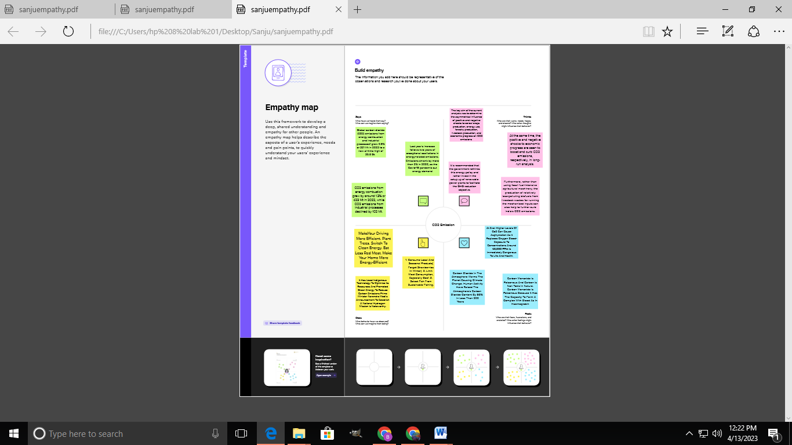

**2.2 Ideation and Brainstorming map screenshots**

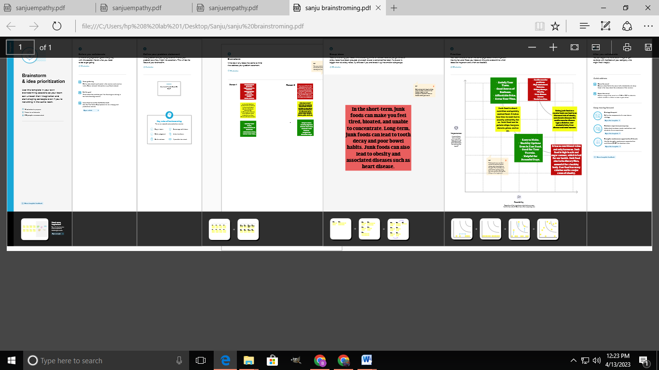

**3. Result**

**Dashboard . 1**

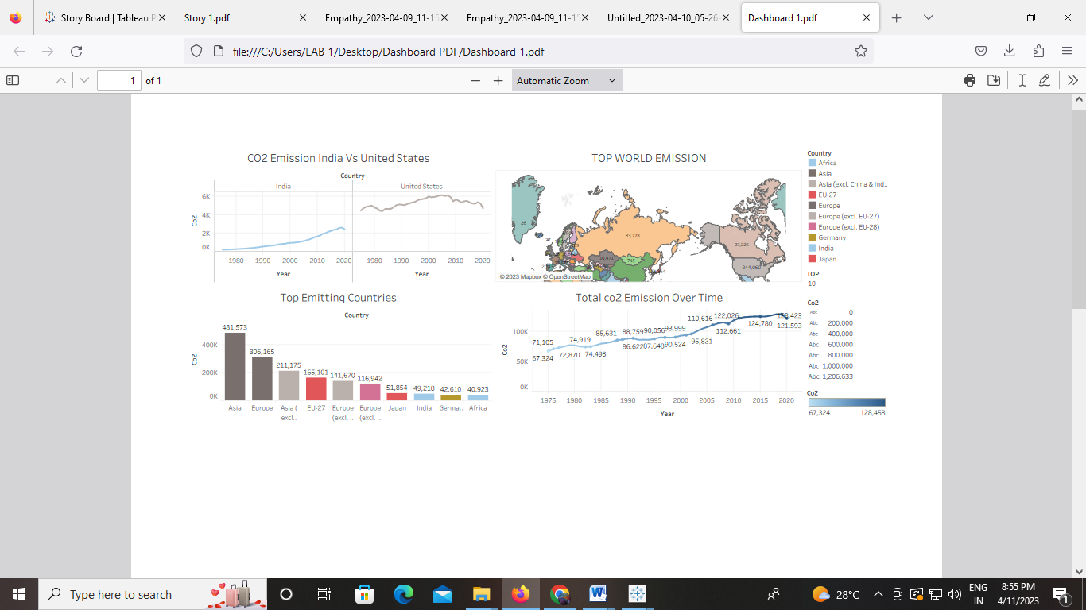

**Dashboard. 2**

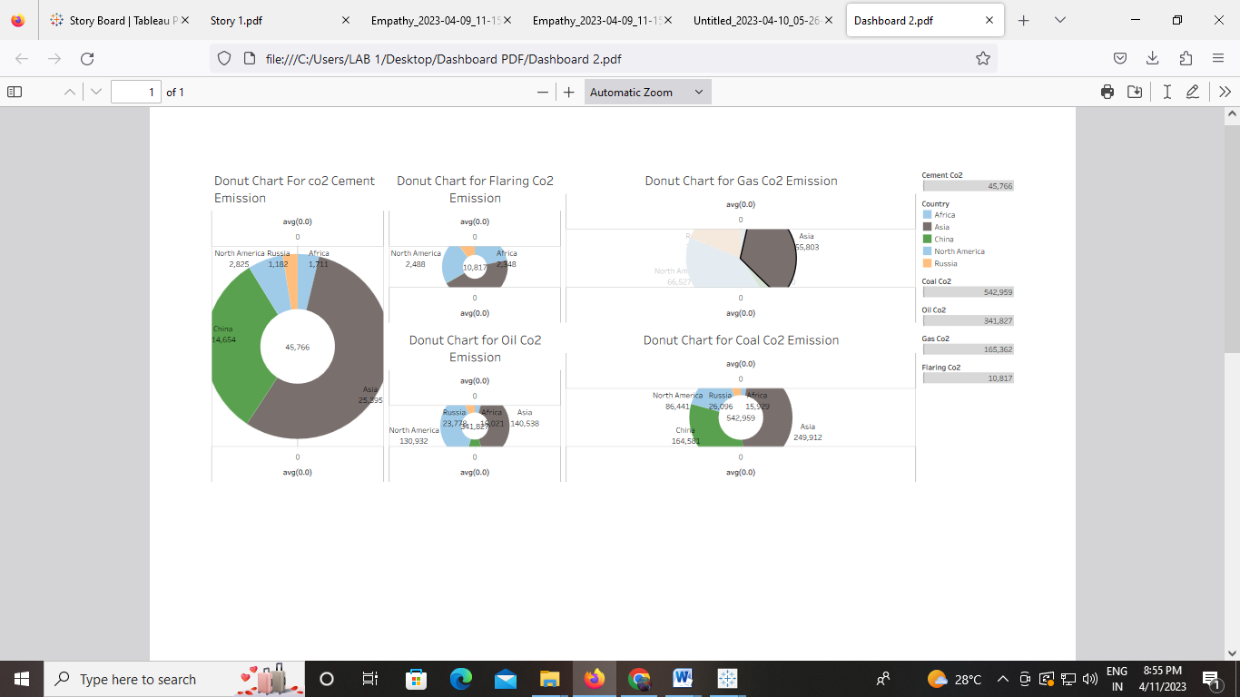

**Dashboard. 3**

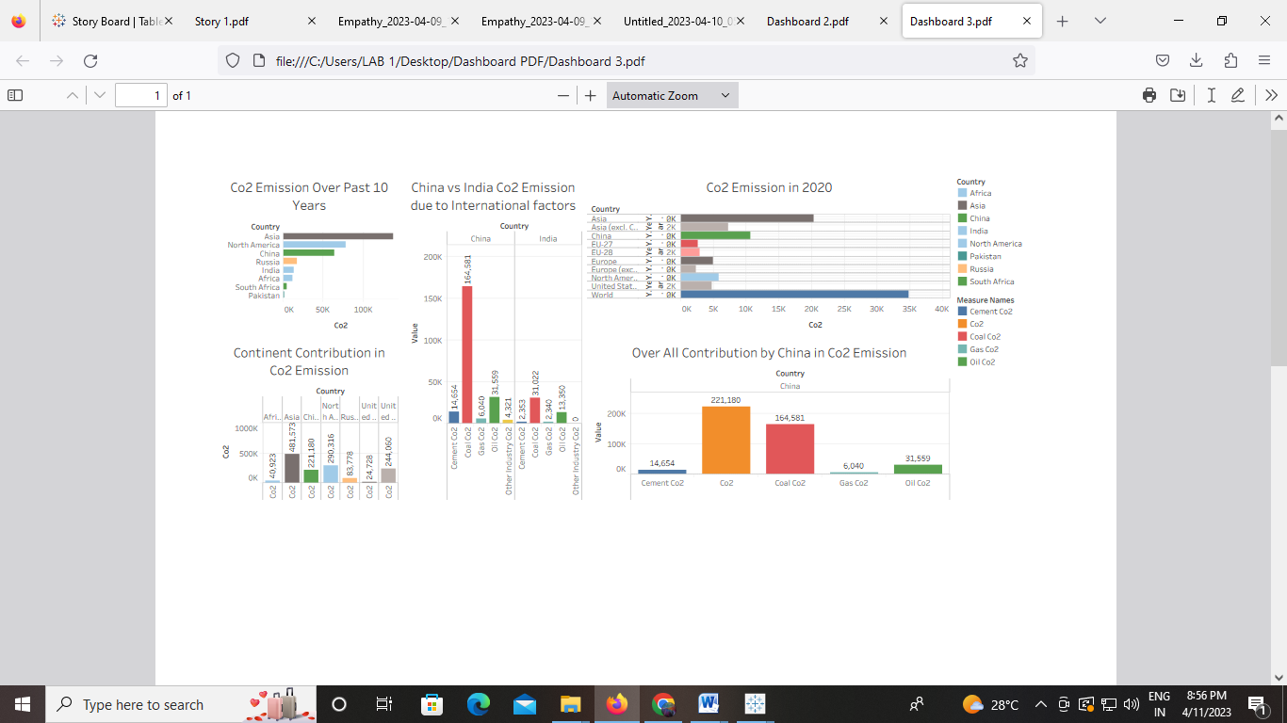

**Dashboard. 4**

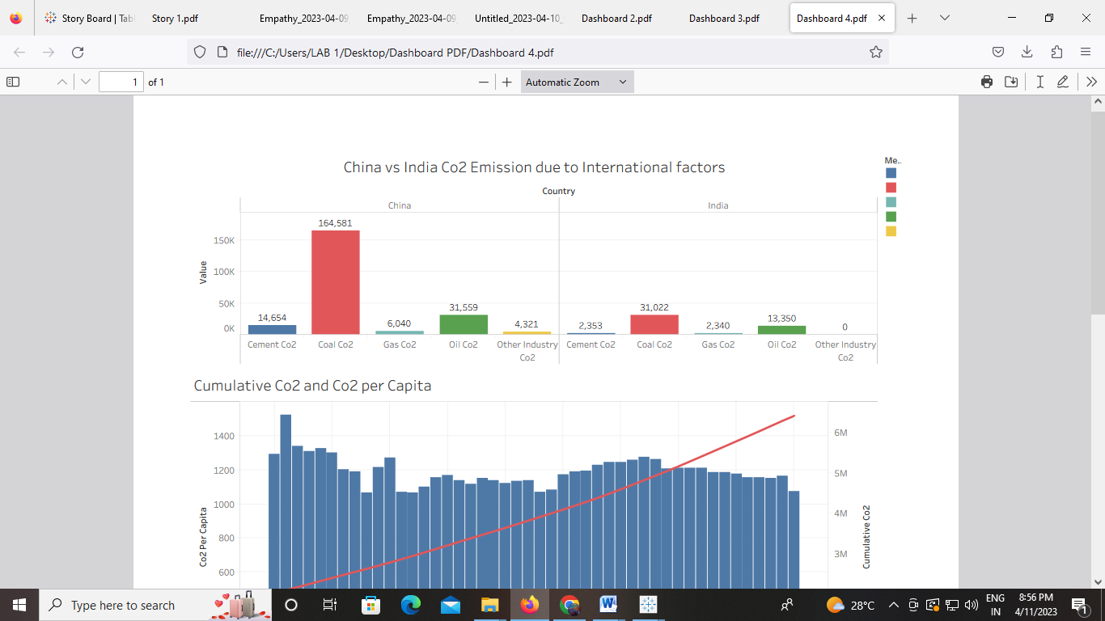

**Story board 1**



**Story board 2**



**Story board 3**



**Story board 4**

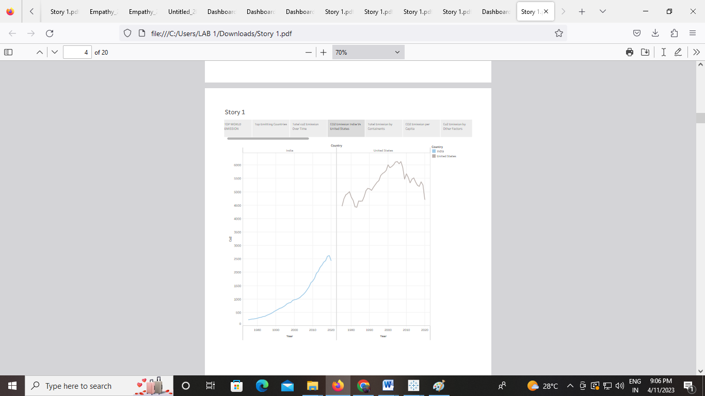

**Story board 5**



**Story board 6**



**Story board 7**

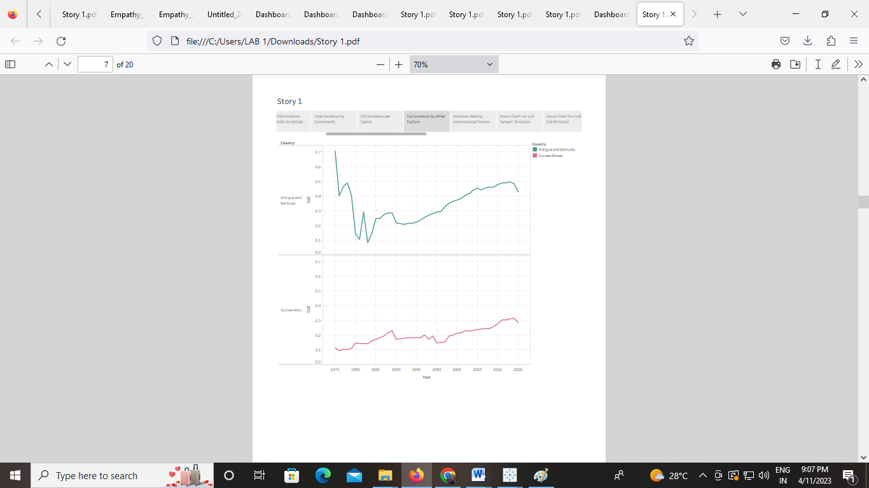

**Story board 8**



**Story board 9**



**Story board 10**



**Story board 11**



**Story board 12**



**Story board 13**



**Story board 14**

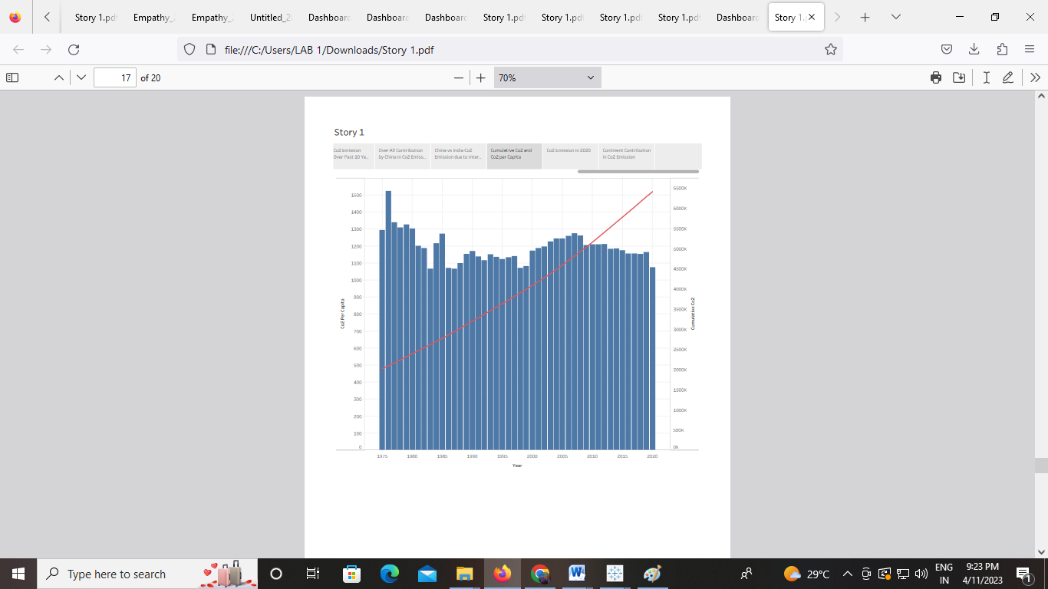

**Story board 15**



**Story board 16**



1. **ADVANTAGES AND DISADVANTAGES**

**CO2 is indeed “plant food”, as well as being essential to a habitable climate!** Both facts are universally known by plant and climate scientists. **Rising CO2 levels in the atmosphere enhance crop yields.** (For C3 crops including wheat, soybean and rice; but not maize and sugarcane. The latter group are already highly productive because they use the C4 photosynthetic pathway, whereby CO2 is concentrated to high levels around the chloroplasts. So in effect, they already have the advantage of a high CO2) Some experiments have shown that the gains can be less than standard plant physiology models predict; but that the gains are real is not in dispute. It follows that these increased yields owing to rising CO2 have undoubtedly diminished pressure to clear further land for agriculture.

**Correction of nutrient deficiencies is common practice already.** The fact that CO2-induced productivity increases may not be fully realised due to nutrient limitations *in natural ecosystems* is largely immaterial for agriculture. **Rising CO2 enhances productivity in natural ecosystems.** The degree to which this effect is limited by nutrient availability is disputed, and seems to be different in different ecosystems (according to experiments). Nonetheless, this CO2 “fertilisation” effect can account (and is the only plausible mechanism) for the fact that terrestrial ecosystems are continuing to take up about a quarter of total anthropogenic emissions of CO2. **Rising CO2 increases the water-use efficiency of plants.** Measurable increases in green vegetation cover are occurring in semi-arid regions, because of this effect .

**Aggregated indicators of human wellbeing continue to increase**, confounding some early predictions of imminent environmental collapse and providing no evidence in support of the idea that CO2-induced climate change *as far as it has occurred already* represents a significant threat to human health or wealth. **Today’s climate models still perform poorly when it comes to predicting local climate changes, or precipitation patterns generally**. Comparing future projections from different models shows their predictions are inconsistent; they can’t all be right. More powerfully, predictions of past eras show that they have systematic biases, which are still not well understood. **There are some likely benefits of rising temperatures that should be weighed up against the hazards**, including (up to a point) crop yields in mid- and high latitudes, and the reduction of excess winter deaths in many parts of the world.

**5 APPLICATION:**

Carbon neutrality is achieving net zero carbon emissions by individuals, organizations, businesses etc. It is done by measuring amount of carbon released and compensating it by preventing equivalent amount of emission from happening somewhere else, or buying enough carbon credits to make up the difference. For instance, a corporation may plant trees in different places to offset the electricity it consumes. Carbon neutrality aims at achieving a zero carbon footprint. All those organizations and individuals seeking carbon neutral status entail reducing and/or avoiding carbon emissions first so that only unavoidable emissions are offset.

**6 CONCLUSION**

"The rising level of atmospheric CO2 could be the one global natural resource that is progressively increasing food production and total biological output, in a world of otherwise diminishing natural resources of land, water, energy, minerals, and fertilizer."  Carbon capture and sequestration is an attractive option for reducing greenhouse gas emissions and could even help remove carbon dioxide from the atmosphere. By adding more carbon dioxide to the atmosphere, people are supercharging the natural greenhouse effect, causing global temperature to rise. Then the example map and various type of graph can help to analyse the percentage of co2 value.

**7 FUTURE SCOPE**

CO2 can also replace fossil fuels as a raw material in chemicals and polymers. Less energy-intensive pathways include reacting CO2 with minerals or waste streams, such as iron slag, to form carbonates for building materials. The future market potential for CO2-derived products and services is difficult to assess.